**NAME:** MUHAMMAD UMER FAHEEM

**STUDENT ID:** F2022054020

**COURSE NAME:** COMPUTER APPLICATIONS

**SECTION:** C1

**DUE DATE:** 20/12/2022

**INSTRUCTOR NAME:** MISS SALWA

TABLE OF CONTENT / TABLE

**Figure 1 AIRLANE RIDES 2**

**Figure 2 A RIDE ON A HORSE 3**

**Figure 3 ITEM MODEL AND SROCK NUMBER 4**

**Figure 4 JEWLLERY EMPIRE 4**

**QUESTION NO 1**

**Letter to corporation**

(MUHAMMAD UMER FAHEEM) Corporation

(12/20/2022)

Ms. Patsy Richardson

123 Main St.

Winnipeg, Manitoba

R2B 5F2

Dear Ms Richardson,

This letter is a confirmation of your request for a ticket to the Annual Fireman’s Ball. Our corporation is happy to provide the ticket to you at **no cost**.

As you will note from the tickets, the Ball is being held **November 25th** at the **Norseman Inn** and will begin promptly at 9 p.m. The famous band, **Cappy’s Capers,** will provide an entertaining evening of dancing and comedy.

Thank you for allowing our company to be of service to you.

Warmest Regards

(MUHAMMAD UMER FAHEEM)

**QUESTION NO 2:**

**You work part-time at Scenic Air. Your boss has asked you to prepare a flyer that advertises aerial tours over the city.**

AIRPLANERIDES

Gain an entirely new vision of Campton By taking an **aerial** tour visitor or Local, business or pleasure, the trip Will change your view of the city

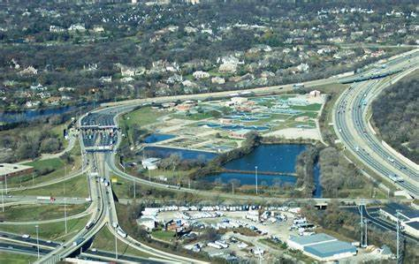

Figure AIRLANE RIDES

* Pilots are licensed and experienced
* 15-, 30- or 60 minutes tours available during daylight hours
* Individual and group rates

**QUESTION NO 3:**

**LEARN TO RIDE**

High quality **western and English** riding lessons, focusing on safety and including instruction on horse care saddling a horse and other aspect of horsemanship

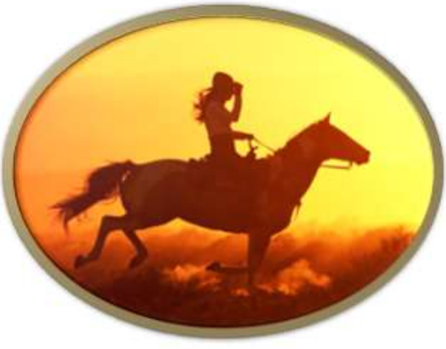

Figure A RIDE ON A HORSE

* Novice to advanced instruction for children and adults indoor and outdoor arenas
* Indoor and outdoor arenas
* $40 per hour for private lessons, $25 for group lessons

*CALL TRI VALLEY STABLES AT 555-2030 TODAY!*

**QUESTION NO 4:**

**Instructions:** Create the table following the given instructions

|  |  |  |
| --- | --- | --- |
| **ITEM** | **MODEL** | **STOCK NUMBER** |
| **9 cubic foot refrigerator** | **Admiral** | **ADC-2698Z-2** |
| **20 cubic foot refrigerator** | **Kelvinator** | **KL5690-LD** |
| **4 burner electric stove** | **Gibson** | **ST900-462** |
| **side-by-side refrigerator** | **Amana** | **AM-1042-Z81** |

Figure ITEM MODEL AND SROCK NUMBER

**Question 5:**

Instructions: Create the blank invoice table shown below

|  |  |  |  |  |  |
| --- | --- | --- | --- | --- | --- |
| **Jewellery Empire**  “Quality Gemstones, Gold and Silver Jewellery for the Discriminating Buyer” | | | | | |
| Bill to:  Name  Address  City/Prov/State  Postal/Zip Code | | | Ship to:  Name  Address  City/Prov/State  Postal/Zip Code | | |
| **QUANTITY** | **ITEM** | **STYLE** | **TYPE** | **UNIT COST** | **COST** |
|  |  |  |  |  |  |
|  |  |  |  |  |  |
|  |  |  |  |  |  |
|  |  |  |  |  |  |
|  |  |  |  |  |  |
|  |  |  |  |  |  |
|  |  |  |  |  |  |
|  |  |  |  |  |  |
|  |  |  |  |  |  |
|  |  |  |  |  |  |
|  |  |  |  |  |  |
|  |  |  |  |  |  |
|  |  |  |  |  |  |
|  |  |  |  |  |  |
|  | | | | **SHIPPING** |  |
| **TAX** |  |
| **TOTAL ORDER** |  |

Figure JEWLLERY EMPIRE